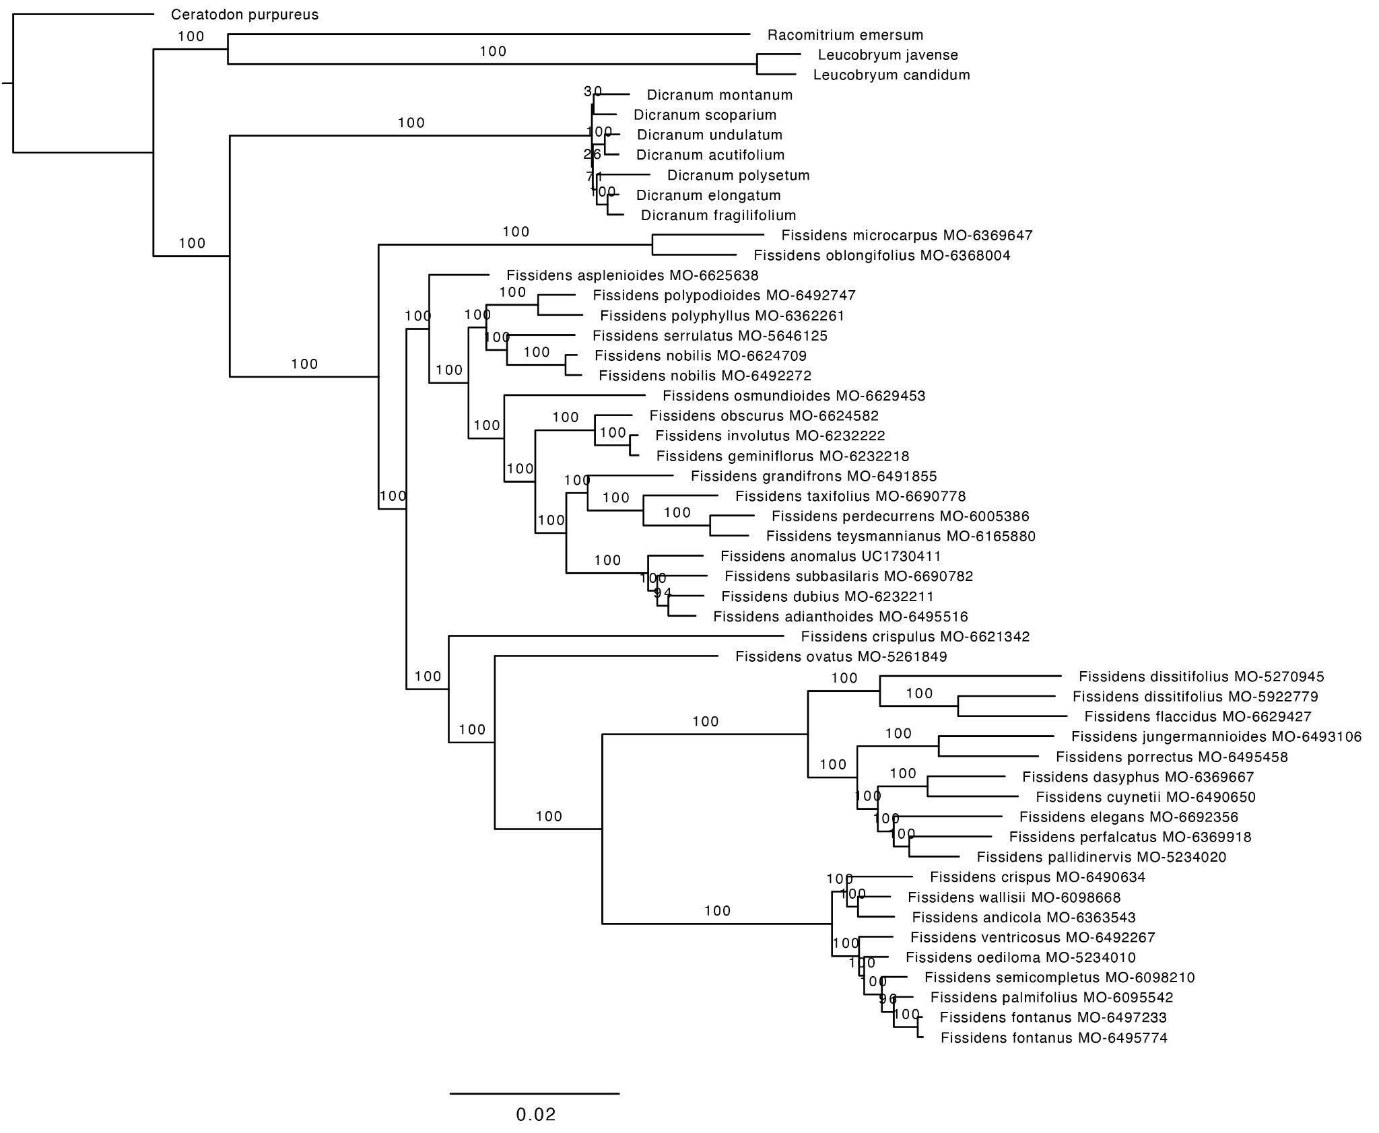

**Fig. S1.** Fissidentaceae Maximum Likelihood phylogram based on the analysis of 404 concatenated exon regions (probe dataset).This included a total aligned supermatrix of 74,441 nucleotides and 94 partitions, using RAxML with the GTRGAMMA substitution model. Branch lengths are proportional to substitutions per site and support from 1,000 rapid bootstrap replicates are indicated by the numbers on the branches.

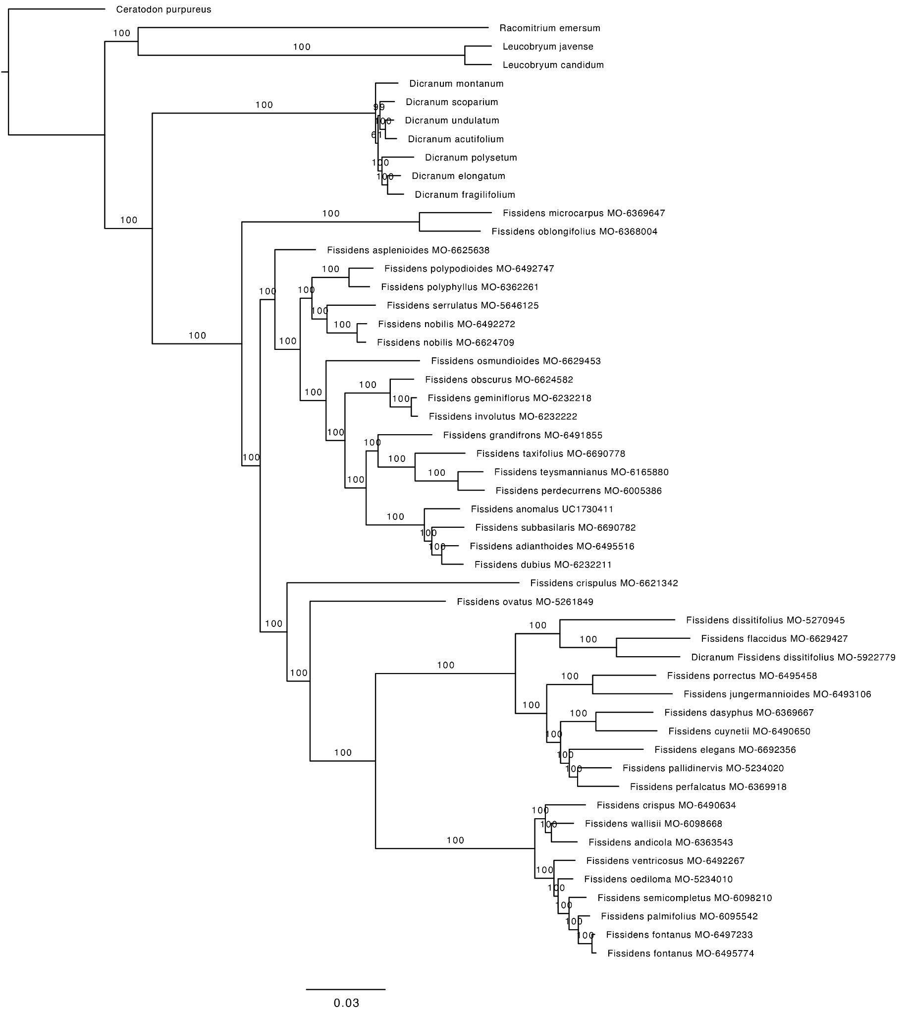

**Fig. S2.** Fissidentaceae Maximum Likelihood phylogram based on the analysis of 404 concatenated exon and the flanking regions (full dataset).This included a total aligned supermatrix of 493,051 nucleotides and 154 partitions, using RAxML with the GTRGAMMA substitution model. Branch lengths are proportional to substitutions per site and support from 1,000 rapid bootstrap replicates are indicated by the numbers on the branches.

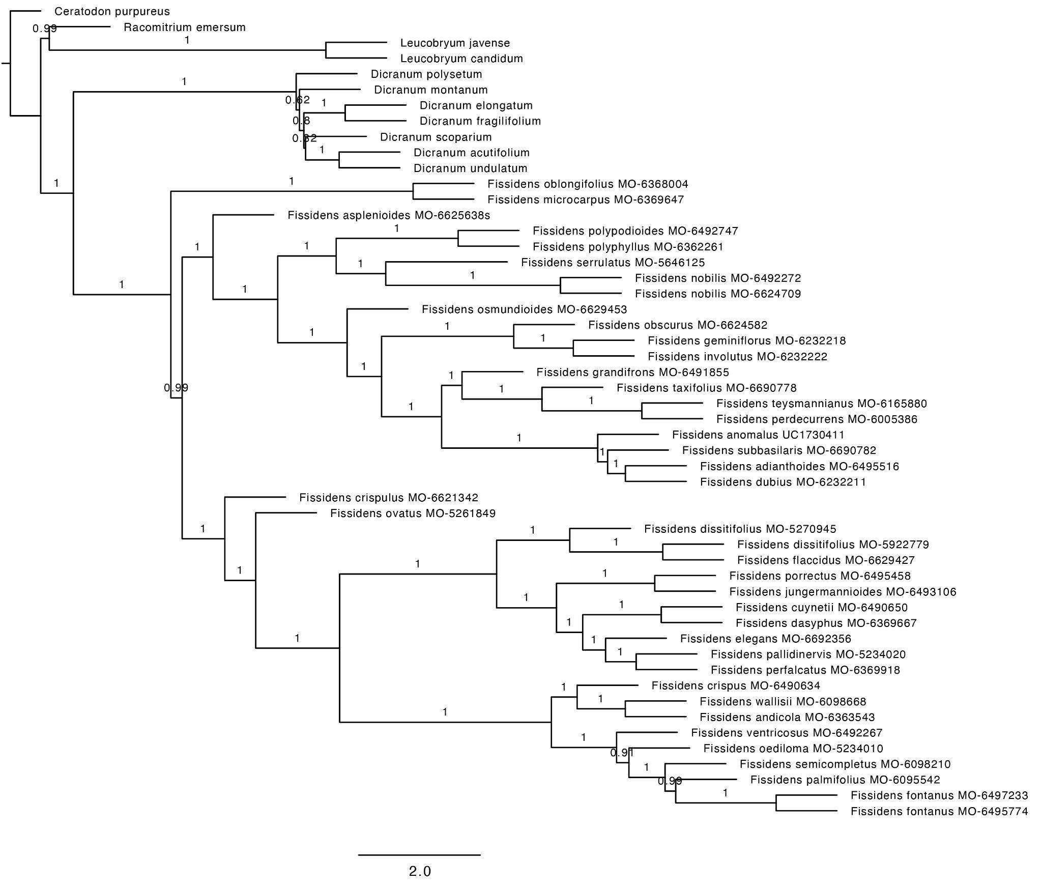

**Fig. S3.** Fissidentaceae species phylogeny. Inferred from 404 RAxML gene trees built from exon regions only (probe dataset) using the summary coalescent method ASTRAL-III with each locus treated as a single partition. Branch lengths are in coalescent units (2*N generations), with support values indicating local posterior probability (LPP).

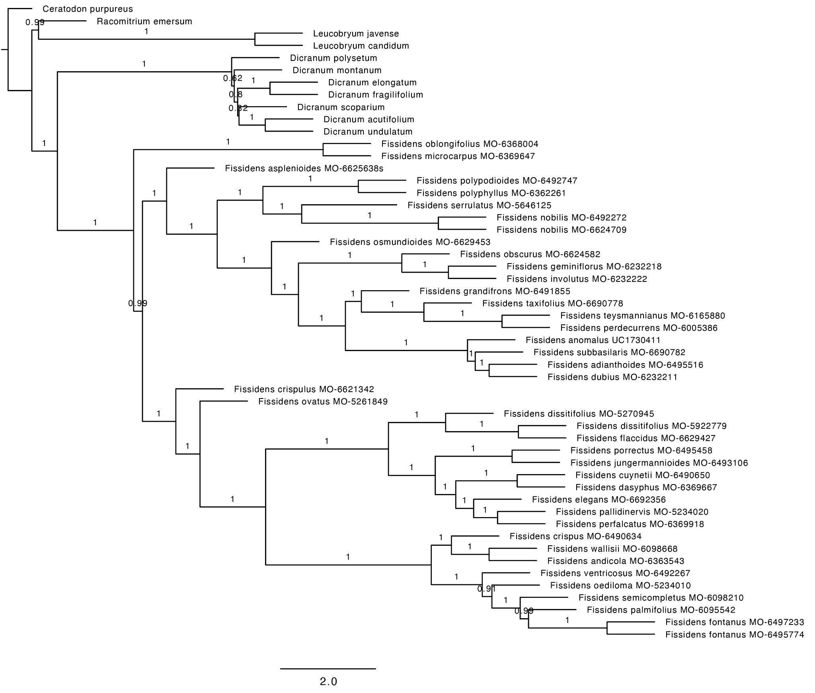

**Fig. S4.** Fissidentaceae species phylogeny. Inferred from 404 RAxML gene trees built from the exon and flanking regions (full dataset) using the summary coalescent method ASTRAL-III with each locus treated as a single partition. Branch lengths are in coalescent units (2*N generations), with support values indicating local posterior probability (LPP).

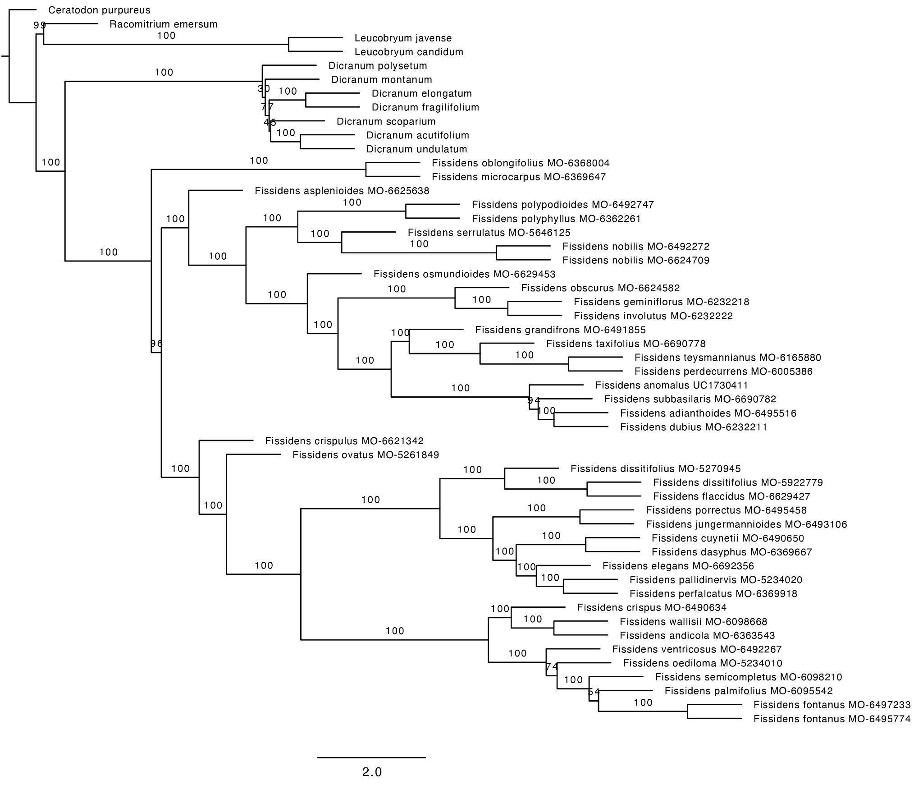

**Fig. S5.** Fissidentaceae species phylogeny. Inferred from 404 RAxML gene trees built from exon regions only (probe dataset) using the summary coalescent method ASTRAL-III with each locus treated as a single partition. Branch lengths are in coalescent units (2*N generations), with support values indicating multilocus bootstrap (MLBS) values from 100 replicates.

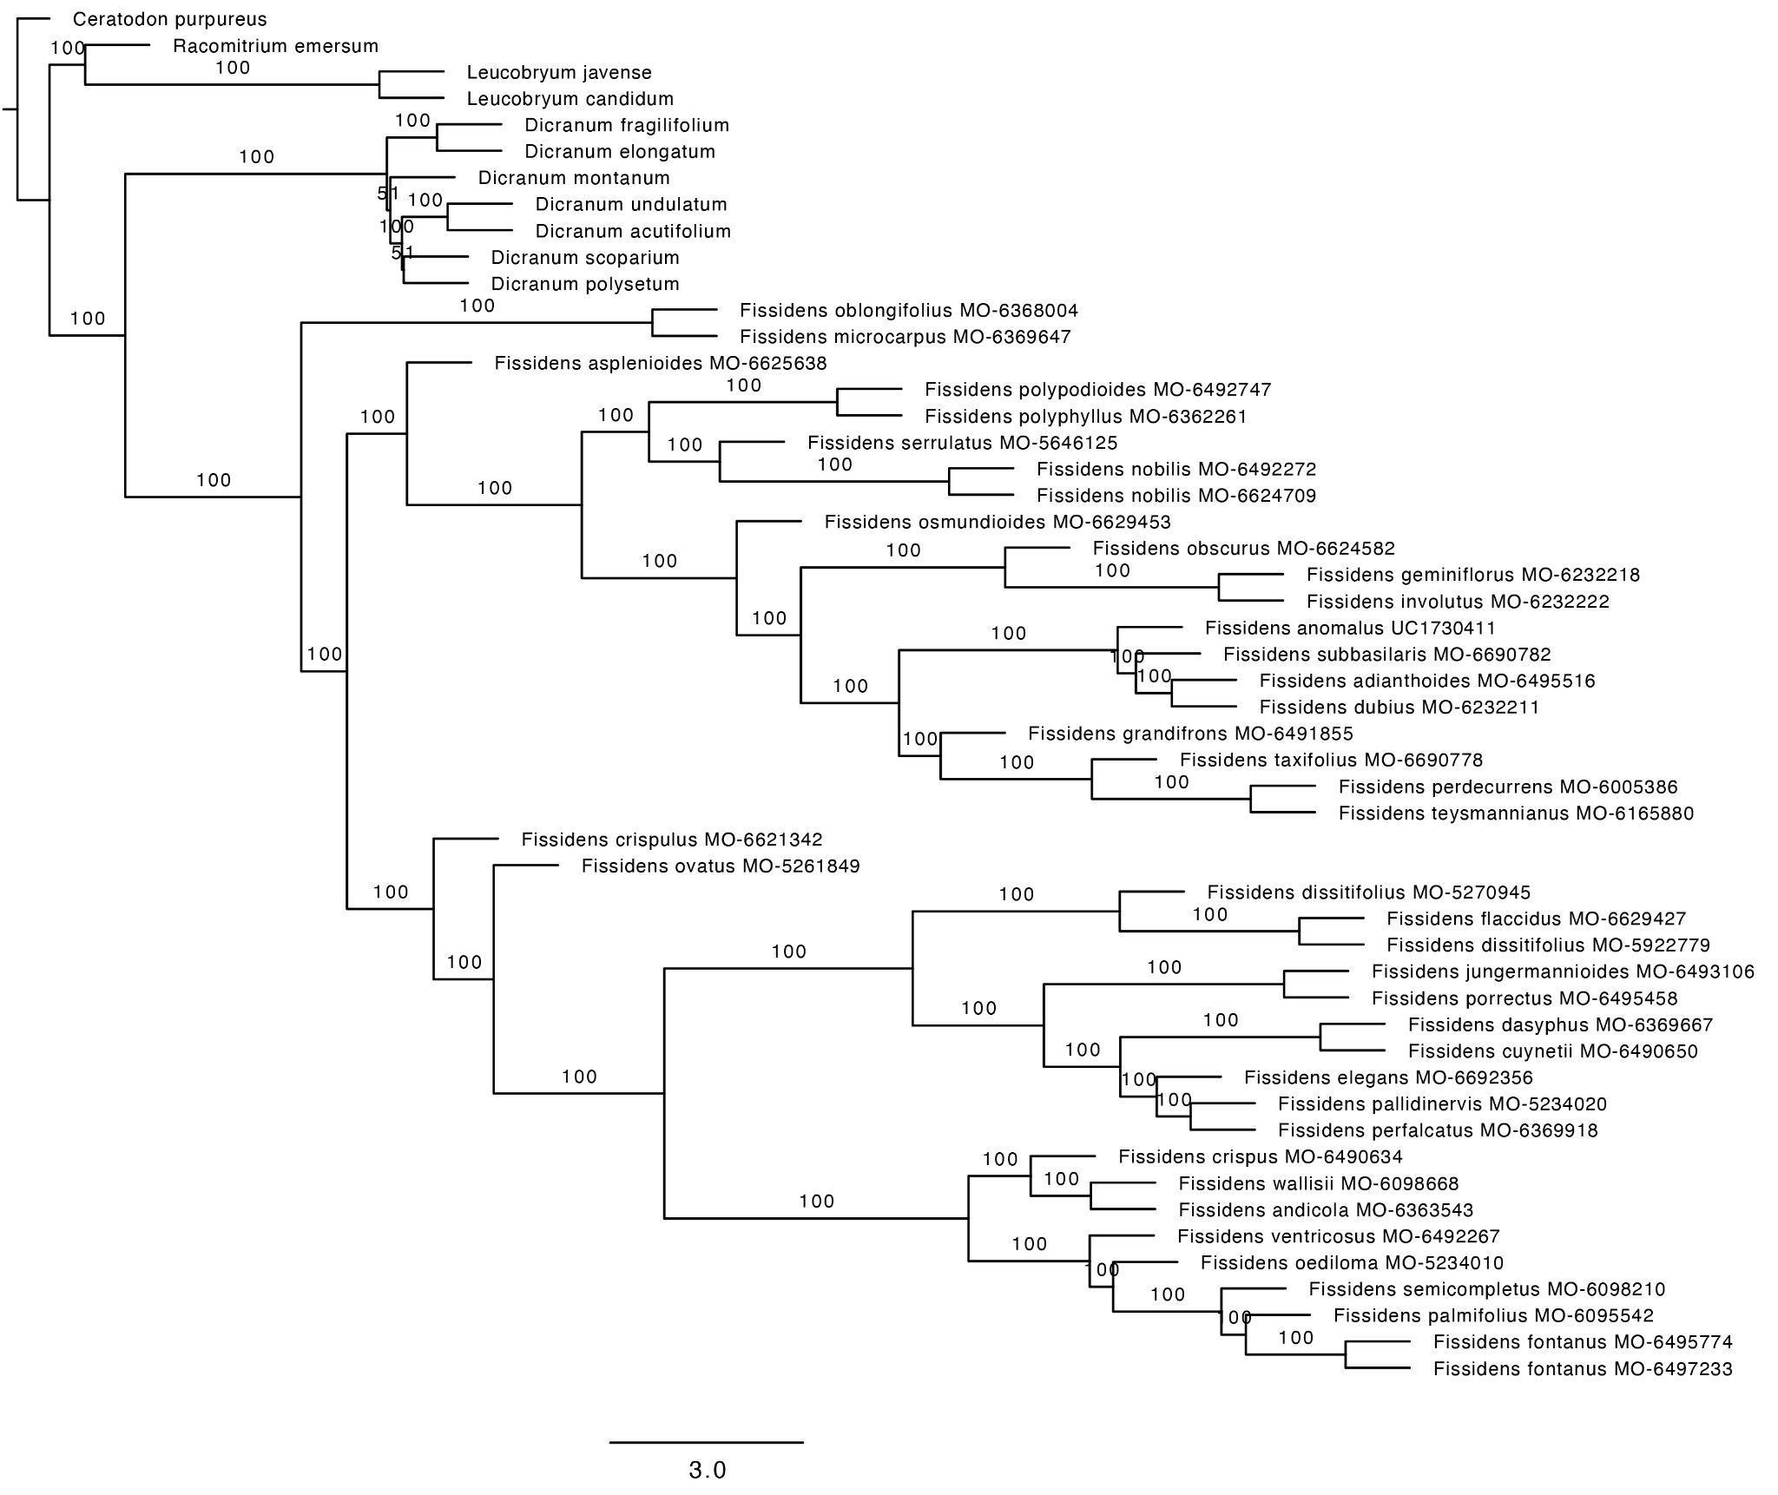

**Fig. S6.** Fissidentaceae species phylogeny. Inferred from 404 RAxML gene trees built from the exon and flanking regions (full dataset) using the summary coalescent method ASTRAL-III with each locus treated as a single partition. Branch lengths are in coalescent units (2*N generations), with support values indicating multilocus bootstrap (MLBS) values from 100 replicates.

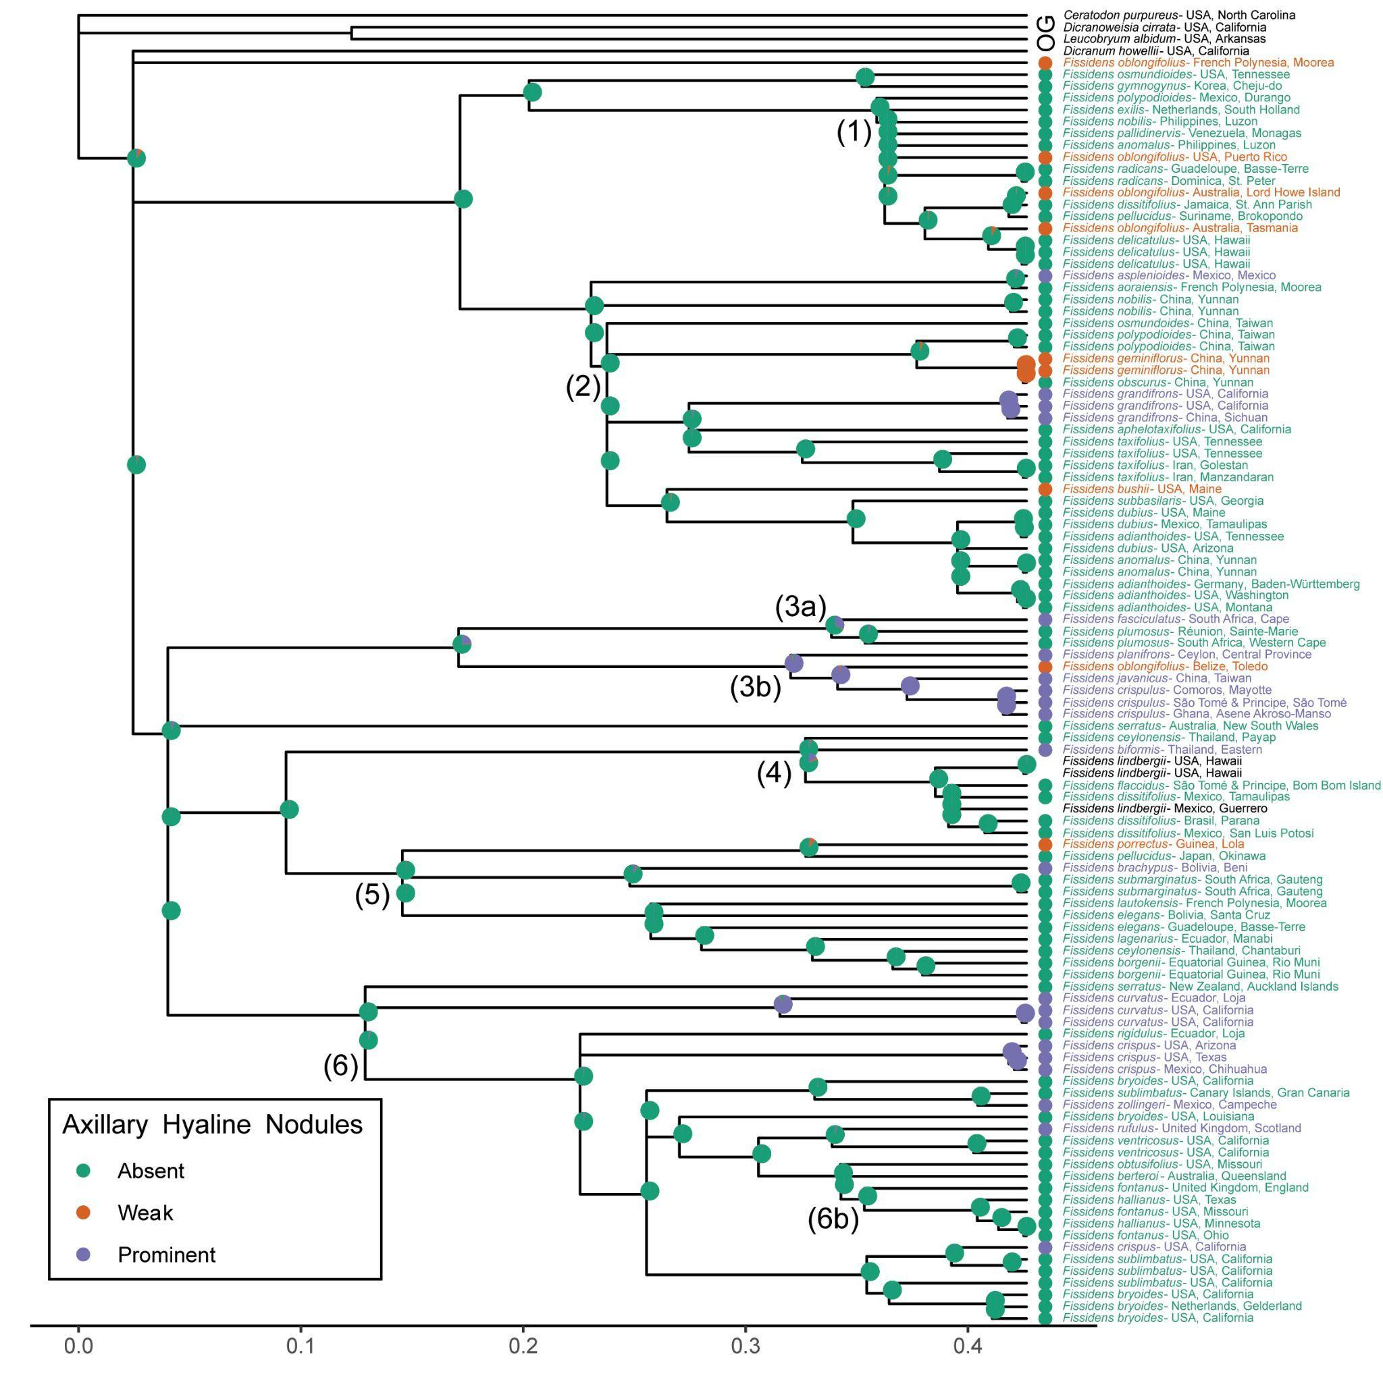

**Fig. S7.** Axillary hyaline nodule character states mapped onto the three-gene Fissidentaceae Bayesian inference majority rule consensus tree using maximum likelihood and an equal rates model. The probability of the states at each node is shown as pie charts representing the proportional likelihood values for each character state. The scale bar represents the number of substitutions per site. The legend indicates the color associated with each character state. Species with missing data are in black text. The major clades, which correspond to the numbered branches in Fig. 2, are indicated on the tree.

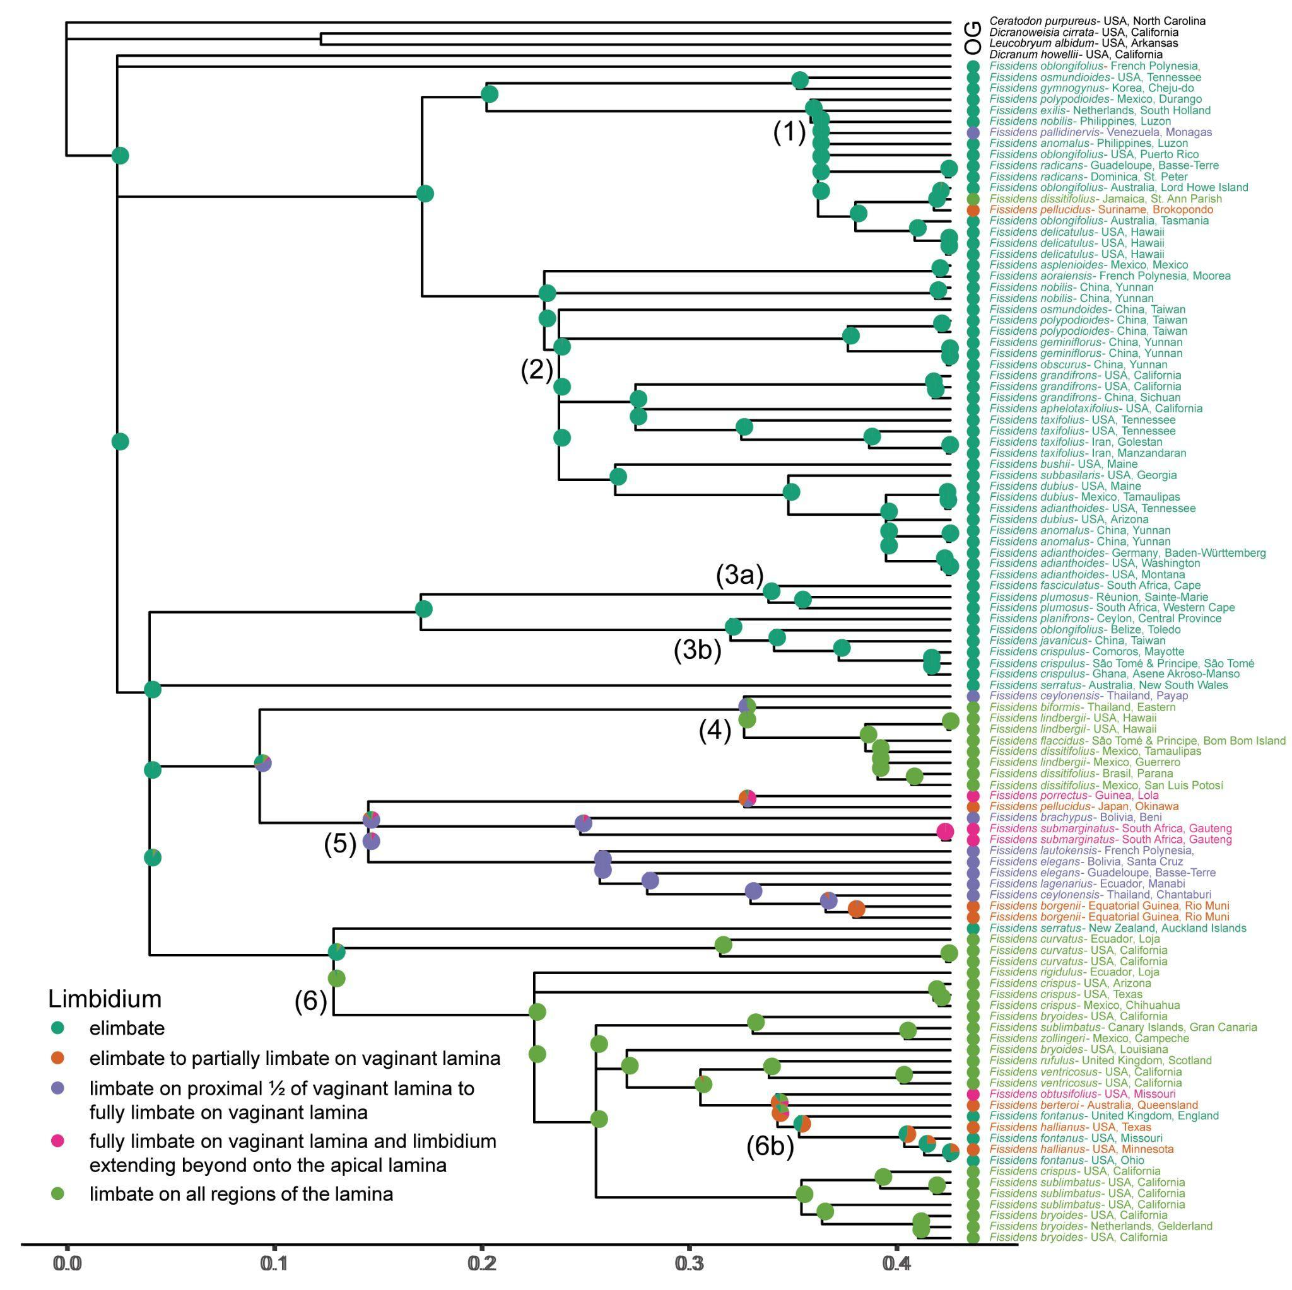

**Fig. S8.** Limbidium character states mapped onto the three-gene Fissidentaceae Bayesian inference majority rule consensus tree using maximum likelihood and an equal rates model. The probability of the states at each node is shown as pie charts representing the proportional likelihood values for each character state. The scale bar represents the number of substitutions per site. The legend indicates the color associated with each character state. Species with missing data are in black text. The major clades, which correspond to the numbered branches in Fig. 2, are indicated on the tree.

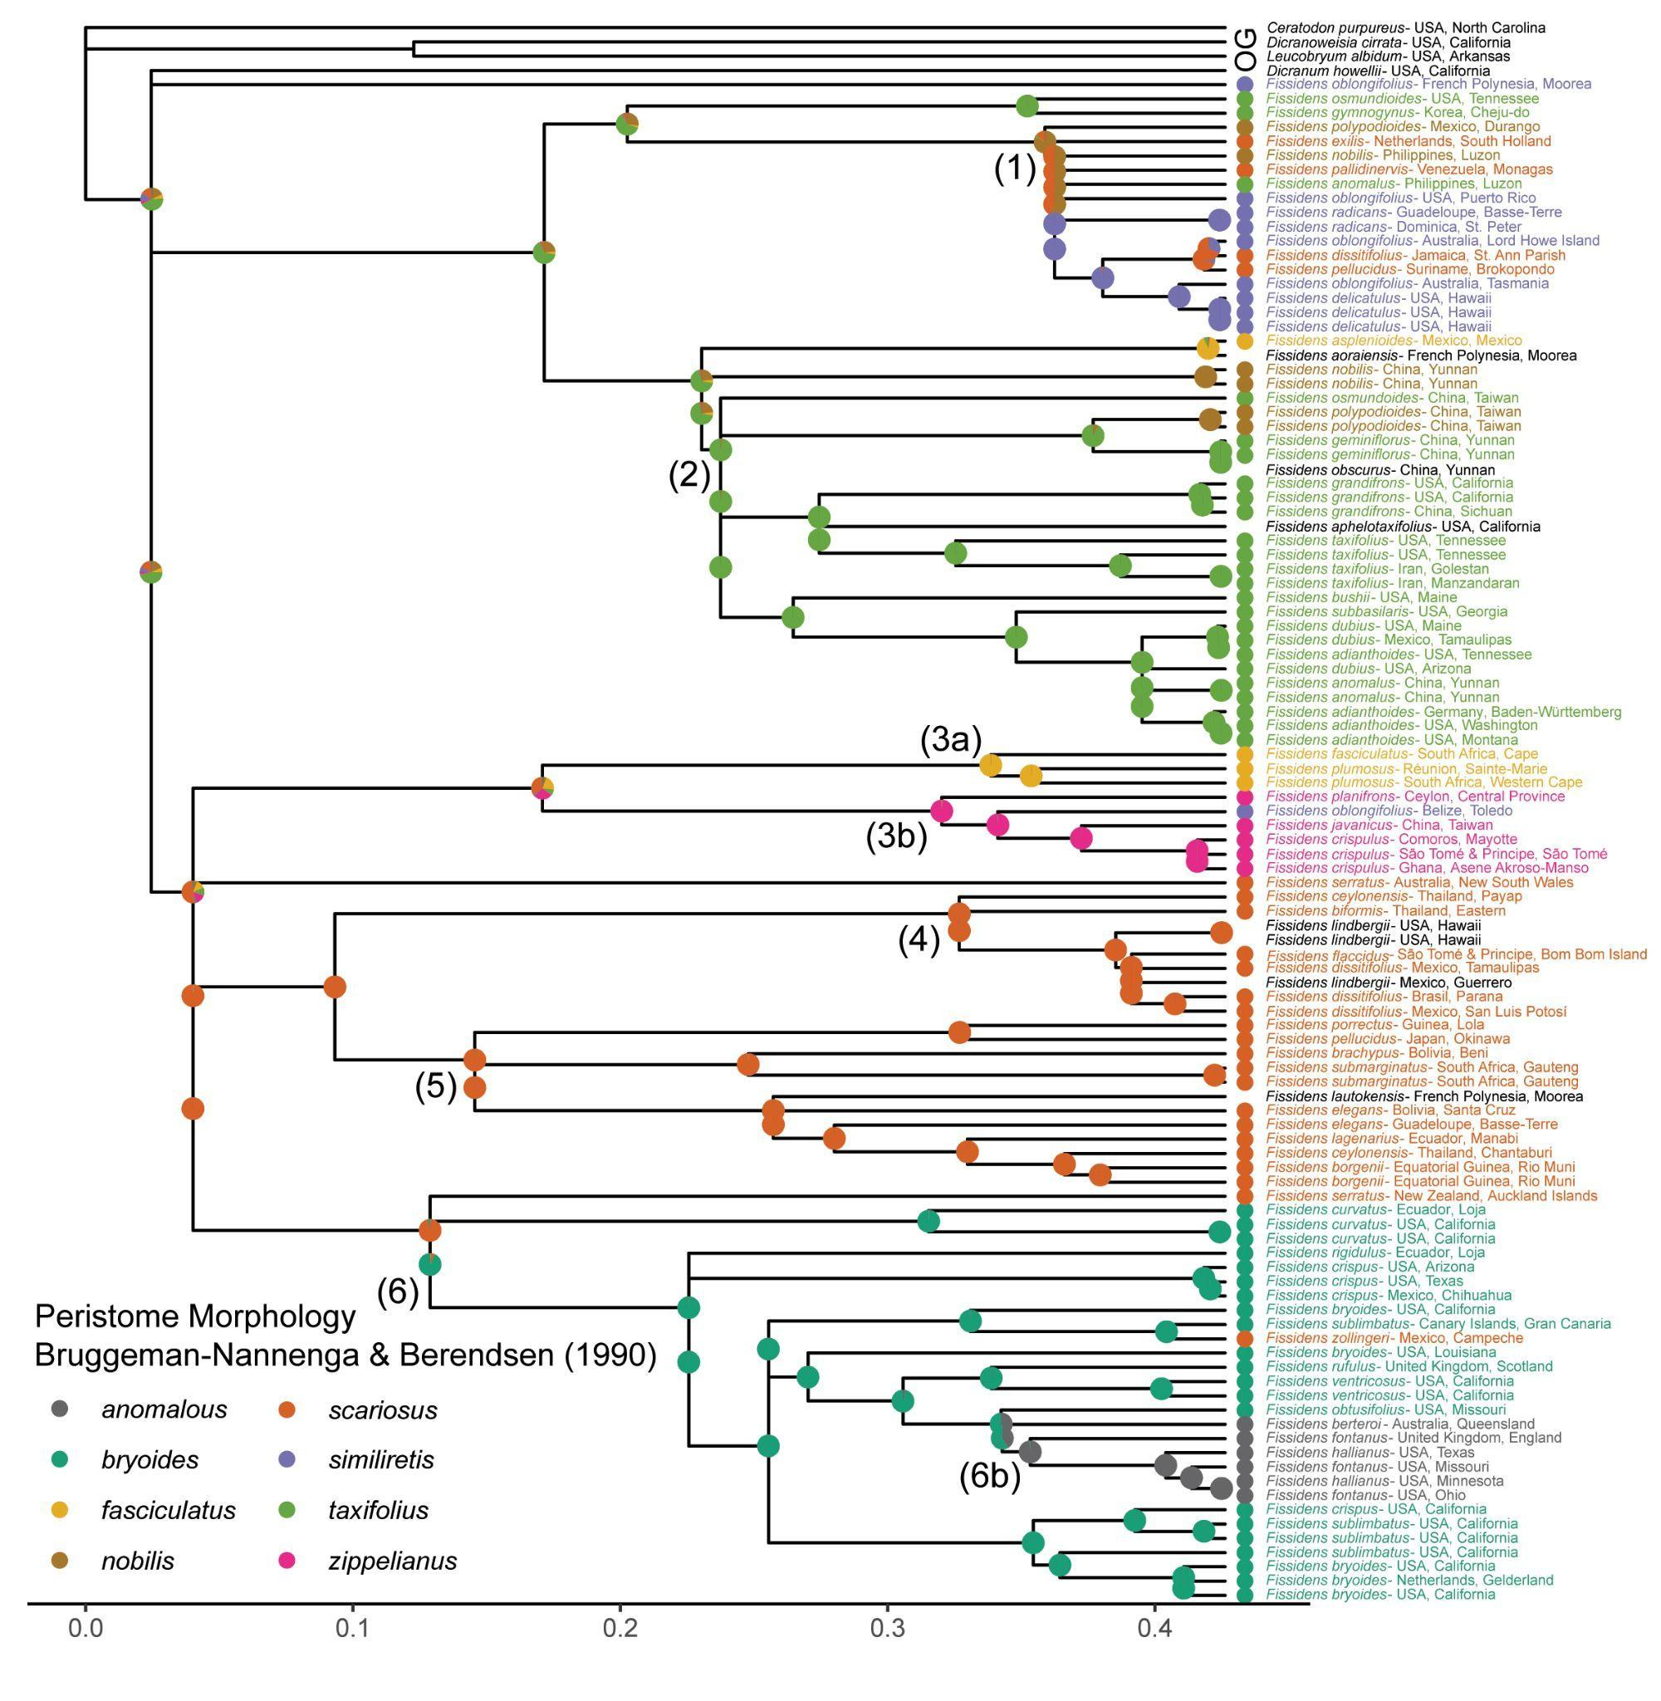

**Fig. S9.** Peristome morphology character states as defined by Bruggeman-Nannenga & Berendsen (1990)mapped onto the three-gene Fissidentaceae Bayesian inference majority rule consensus tree using maximum likelihood and an equal rates model. The probability of the states at each node is shown as pie charts representing the proportional likelihood values for each character state. The scale bar represents the number of substitutions per site. The legend indicates the color associated with each character state. Species with missing data are in black text. The major clades, which correspond to the numbered branches in Fig. 2, are indicated on the tree.

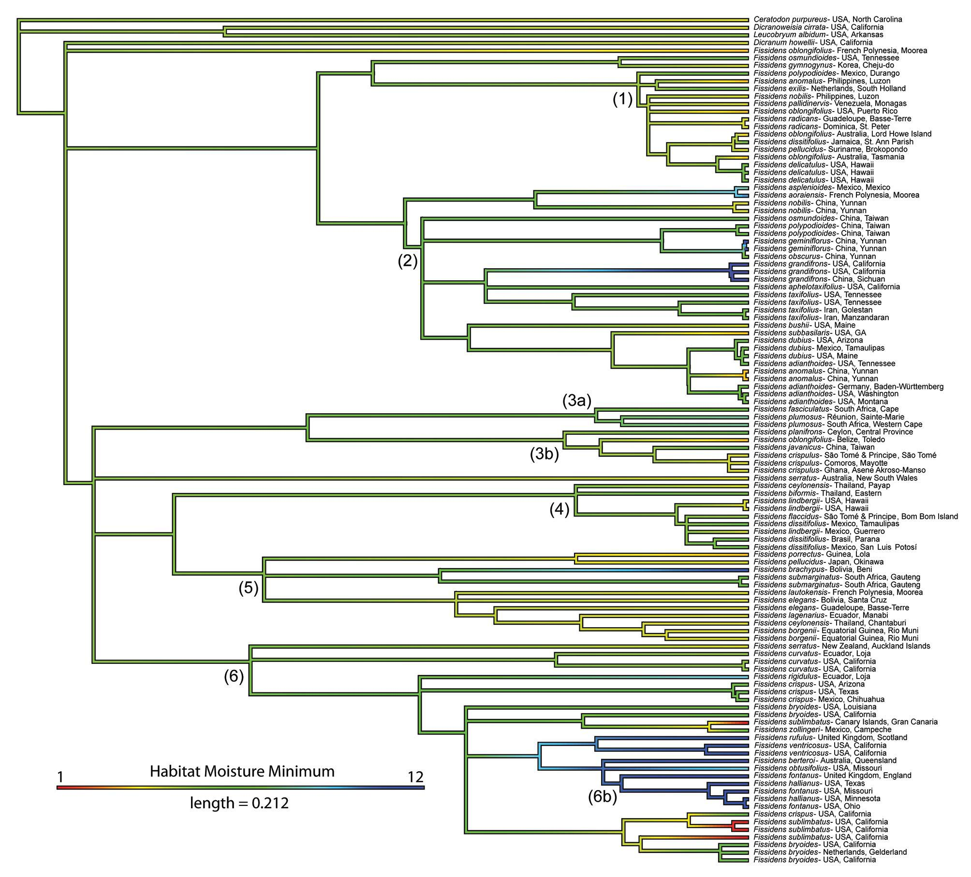

**Fig. S10.** Continuous character state mapping of the habitat moisture minimum*,* ranging from 1 (red) to 12 (blue), onto the three-gene Fissidentaceae Bayesian inference tree. The length of the colored scale bar represents the number of substitutions per site. The major clades, which correspond to the numbered branches in Fig. 2, are indicated on the tree.

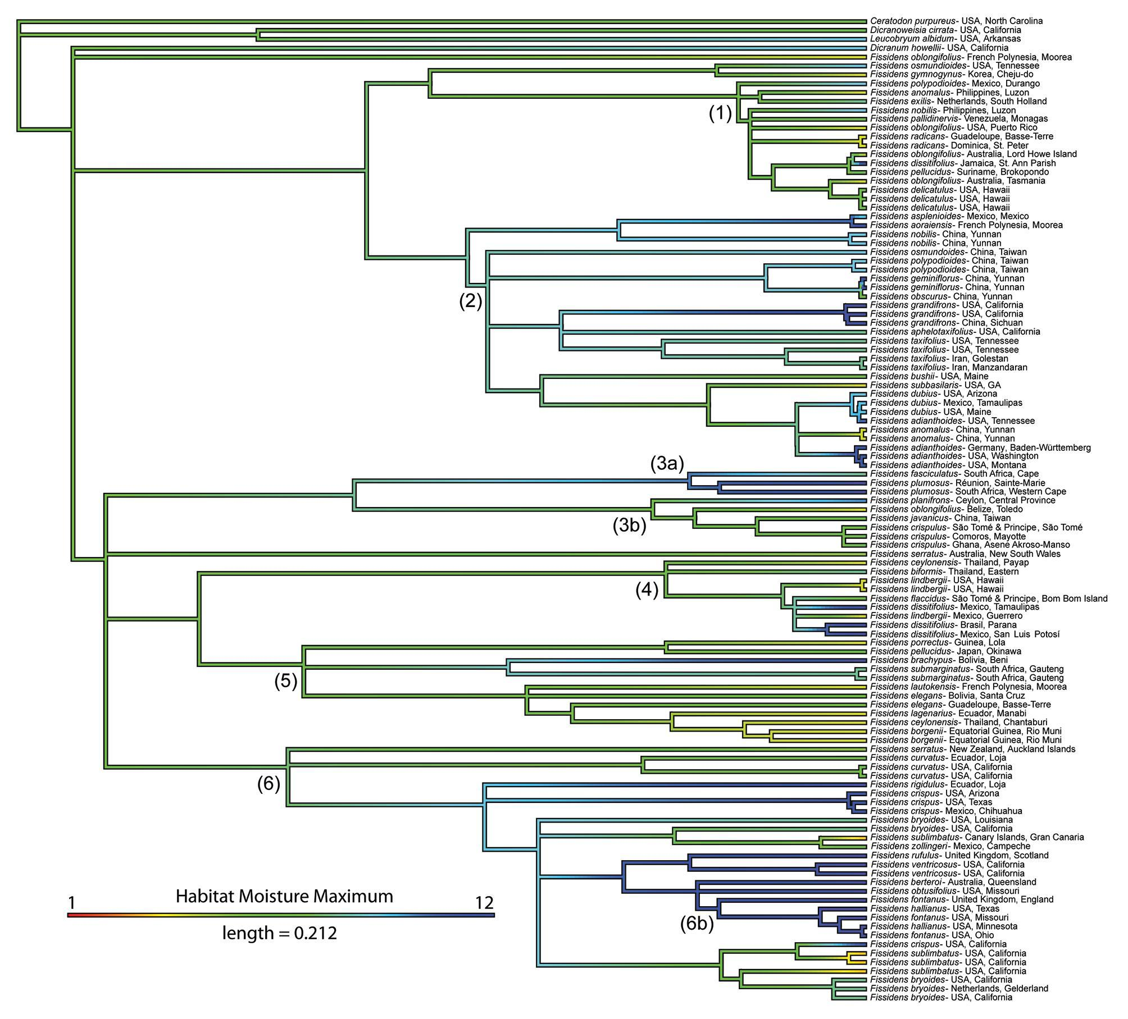

**Fig. S11.** Continuous character state mapping of the habitat moisture maximum*,* ranging from 1 (red) to 12 (blue), onto the three-gene Fissidentaceae Bayesian inference tree. The length of the colored scale bar represents the number of substitutions per site. The major clades, which correspond to the numbered branches in Fig. 2, are indicated on the tree.

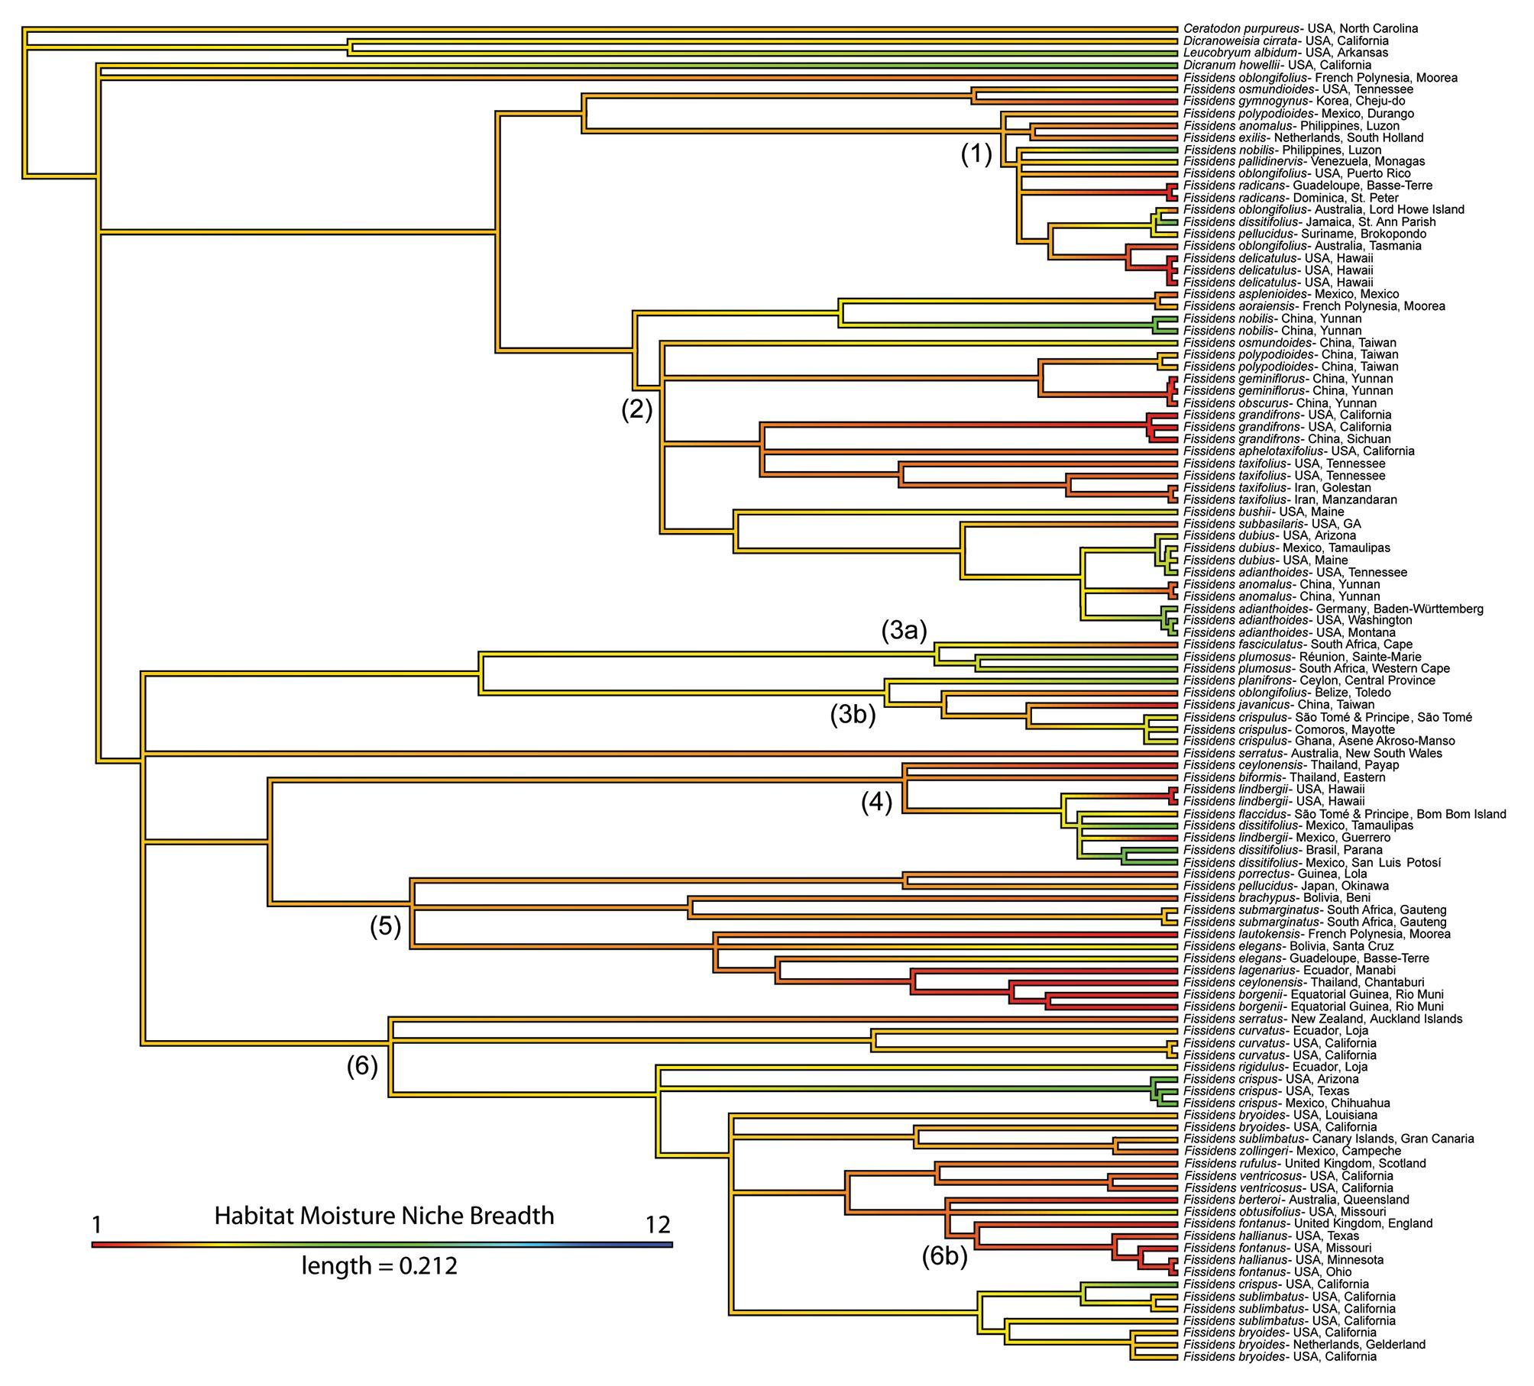

**Fig. S12.** Continuous character state mapping of the habitat moisture niche breadth*,* ranging from 1 (red) to 12 (blue), onto the three-gene Fissidentaceae Bayesian inference tree. The length of the colored scale bar represents the number of substitutions per site. The major clades, which correspond to the numbered branches in Fig. 2, are indicated on the tree.

**Table S1.** Herbarium specimens sampled for phylogenetic analyses.

|  |  |  |  |  |  |  |  |  |  |  |
| --- | --- | --- | --- | --- | --- | --- | --- | --- | --- | --- |
|  | Species | Authority | Herbarium Accession Number | Collector & Collection Number | Locality | Determined by | Genbank Accession Number GoFlag Data | Genbank Accession Number trnA | Genbank Accession Number trnL-F | Genbank Accession Number ITS2 |
| GoFlag | *Ceratodon purpureus* | (Hedw.) Brid. | NYSi2774 | Miller, N.G. 18,934 | USA, New York | S.F. McDaniel | SAMN14888298 | NA | NA | NA |
| Three-gene | *Ceratodon purpureus* | (Hedw.) Brid. | TENN-B-0013173 | P.G. Davison s.n. | USA, North Carolina | D.K. Smith | NA | OL516465 | OL516362 | OL457714 |
| Three-gene | *Dicranoweisia cirrata* | (Hedw.) Lindb. | TENN-B-0019070 | D.H. Norris 68366 | USA, California | D.H. Norris | NA | OL516466 | OL516363 | OL457713 |
| GoFlag | *Dicranum acutifolium* | (Lindb. & Arnell) C.E.O. Jensen | FLAS | Moss Dimensions Team 394 | USA, Alaska | S.F. McDaniel | SAMN14888300 | NA | NA | NA |
| GoFlag | *Dicranum elongatum* | Schleich. ex Schwägr. | FLAS | Moss Dimensions Team 395 | USA, Alaska | S.F. McDaniel | SAMN14888301 | NA | NA | NA |
| GoFlag | *Dicranum fragilifolium* | Lindb. | FLAS | Moss Dimensions Team 396 | USA, Alaska | S.F. McDaniel | SAMN14888302 | NA | NA | NA |
| Three-gene | *Dicranum howellii* | Renauld & Cardot | DAV236939 | M. Berbee 15 | USA, California | S.P. Rae | NA | OL516468 | OL516365 | OL457715 |
| GoFlag | *Dicranum montanum* | Hedw. | FLAS | Moss Dimensions Team 397 | USA, Alaska | S.F. McDaniel | SAMN14888303 | NA | NA | NA |
| GoFlag | *Dicranum polysetum* | Sw. | FLAS | Moss Dimensions Team 398 | USA, Alaska | S.F. McDaniel | SAMN14888304 | NA | NA | NA |
| GoFlag | *Dicranum scoparium* | Hedw. | FLAS | Moss Dimensions Team 399 | USA, Alaska | S.F. McDaniel | SAMN14888305 | NA | NA | NA |
| GoFlag | *Dicranum undulatum* | Schrad. ex Brid. | FLAS | Moss Dimensions Team 400 | USA, Alaska | S.F. McDaniel | SAMN14888306 | NA | NA | NA |
| GoFlag | *Fissidens adianthoides* | Hedw. | MO-6495516 | N.J. Holmberg 4722 | USA, Missouri | J.M. Budke | SRR17180445 | NA | NA | NA |
| Three-gene | *Fissidens adianthoides* | Hedw. | UC1721886 | D.H. Norris 90352 | USA, Washington | J.M. Budke | NA | OL516476 | OL516369 | OL457724 |
| Three-gene | *Fissidens adianthoides* | Hedw. | UC1739115 | J.R. Shevock 15405 | USA, Montana | J.M. Budke | NA | OL516567 | OL516368 | NA |
| Three-gene | *Fissidens adianthoides* | Hedw. | TENN-B-0025613 | D.K. Smith & P.G. Davison 185 | USA, Tennessee | J.M. Budke | NA | OL516471 | OL516381 | OL457721 |
| Three-gene | *Fissidens adianthoides* | Hedw. | MO-6690398 | Schäfer-Verwimp & Verwimp 35877 | Germany, Baden-Württemberg | J.M. Budke | NA | OL516473 | OL516366 | OL457725 |
| GoFlag | *Fissidens andicola* | (Herzog) Brugg.-Nann. | MO-6363543 | S. Carreño & Y. Inturias 219 | Bolivia, Chuquisaca | S.P. Churchill | SRR17180444 | NA | NA | NA |
| Three-gene | *Fissidens anomalus* | Mont. | UC1933948 | J.R. Shevock 27246 | China, Yunnan | J.M. Budke | NA | OL516475 | OL516370 | OL457722 |
| Three-gene | *Fissidens anomalus* | Mont. | TENN-B-0103458 | Z. Iwatsuki, A.J. Sharp, & E. Sharp 14173 | Philippines, Luzon | J.M. Budke | NA | NA | NA | OL457734 |
| Three-gene & GoFlag | *Fissidens anomalus* | Mont. | UC1730411 | J.R. Shevock 31078 with D.G. Long & X. Fan | China, Yunnan | J.M. Budke | SRR17180433 | OL516474 | OL516371 | OL457723 |
| Three-gene | *Fissidens aoraiensis* | H. Whittier & H.A. Mill. | UC1773059 | D.P. Wall 434 | French Polynesia, Moorea | J.M. Budke | NA | OL516505 | OL516417 | OL457785 |
| Three-gene | *Fissidens aphelotaxifolius* | R.A. Pursell | UC1741874 | J.R. Shevock 20225 with D. Norris, C. Beyer, & M. Price | USA, California | J.M. Budke | NA | OL516482 | OL516377 | OL457727 |
| GoFlag | *Fissidens asplenioides* | Hedw. | MO-6625638 | R.R. Ireland & G. Bellolio 35749 | Chile, Bíobío | J.M. Budke | SRR17180422 | NA | NA | NA |
| Three-gene | *Fissidens asplenioides* | Hedw. | UC1779379 | A. Cardenas S. 3208 | Mexico, Mexico | J.M. Budke | NA | OL516489 | OL516386 | OL457728 |
| Three-gene | *Fissidens berterii* | (Mont.) Müll. Hal. | MO-6692035 | D.H. Norris 35417 | Australia, Queensland | J.M. Budke | NA | OL516541 | OL516448 | OL457762 |
| Three-gene | *Fissidens biformis* | Mitt. | ALTA046086 | Larsen, Santisuk, & Warncke 3283 | Thailand, Eastern | S. He | NA | OL516520 | OL516437 | NA |
| Three-gene | *Fissidens borgenii* | Hampe | UC1944532 | D.H. Norris 106036 with P. Heras & M. Infante | Equatorial Guinea, Rio Muni | J.M. Budke | NA | OL516512 | OL516420 | OL457787 |
| Three-gene | *Fissidens borgenii* | Hampe | UC1944527 | D.H. Norris 105853 with P. Heras & M. Infante | Equatorial Guinea, Rio Muni | J.M. Budke | NA | OL516513 | OL516421 | OL457788 |
| Three-gene | *Fissidens brachypus* | Mitt. | MO-6094962 | D. Rocabado & E. Calzadilla 1005 | Bolivia, Beni | S.P. Churchill | NA | OL516507 | OL516428 | OL457794 |
| Three-gene | *Fissidens bryoides* | Hedw. | UC1771471 | M.J. Lenz 611 | USA, California | J.M. Budke | NA | OL516543 | OL516463 | OL457769 |
| Three-gene | *Fissidens bryoides* | Hedw. | UC1712650 | J.R. Shevock 16855 with D. Norris | USA, California | J.M. Budke | NA | OL516502 | NA | OL457774 |
| Three-gene | *Fissidens bryoides* | Hedw. | UC1782678 | J.R. Shevock 24824 with K. Kellman | USA, California | J.M. Budke | NA | OL516536 | OL516449 | OL457772 |
| Three-gene | *Fissidens bryoides* | Hedw. | MO-6695707 | R.A. Pursell et al. 12273 | Netherlands, Gelderland | J.M. Budke | NA | OL516534 | OL516462 | OL457773 |
| Three-gene | *Fissidens bryoides* | Hedw. | MO-6695706 | R.A. Pursell & B. Allen 12240 | USA, Louisiana | J.M. Budke | NA | OL516542 | OL516441 | OL457809 |
| Three-gene | *Fissidens bushii* | (Cardot & Thér.) Cardot & Thér. | UC1918190 | D.H. Norris 109180 & N. Hillyard | USA, Maine | D.H. Norris | NA | OL516477 | OL516372 | OL457726 |
| Three-gene | *Fissidens ceylonensis* | Dozy & Molk. | ALTA044970 | K. Larsen, T. Smitinand, & E. Warncke 1697 | Thailand, Chantaburi | J.M. Budke | NA | OL516506 | OL516397 | OL457786 |
| Three-gene | *Fissidens ceylonensis* | Dozy & Molk. | ALTA044969 | A. Touw 9415 | Thailand, Payap | J.M. Budke | NA | OL516565 | OL516419 | OL457795 |
| GoFlag | *Fissidens crispulus* | Brid. | MO-6621342 | S. He 44264 | Laos, Luang Namtha | J.M. Budke | SRR17180411 | NA | NA | NA |
| Three-gene | *Fissidens crispulus* | Brid. | MO-3992381 | R.E. Magill & T. Pócs 11592 | Comoros, Mayotte | R.A. Pursell | NA | OL516499 | OL516409 | NA |
| Three-gene | *Fissidens crispulus* | Brid. | MO-6695510 | J.R. Shevock & M. Nadel 40092 | São Tomé & Principe, São Tomé | R.A. Pursell | NA | OL516497 | OL516410 | NA |
| Three-gene | *Fissidens crispulus* | Brid. | E00848203 | G. Ameka 213 | Ghana, Asene Akroso-Manso | J.M. Budke | NA | NA | OL516411 | NA |
| GoFlag | *Fissidens crispus* | Mont. | MO-6490634 | B. Allen 30710 | Guinea, Lola | J.M. Budke | SRR17180406 | NA | NA | NA |
| Three-gene | *Fissidens crispus* | Mont. | UC1739497 | J.R. Shevock 19175 | USA, California | J.M. Budke | NA | OL516539 | OL516454 | OL457775 |
| Three-gene | *Fissidens crispus* | Mont. | UC1797946 | J.R. Shevock 29566 with K. Kellman | USA, Arizona | J.M. Budke | NA | OL516544 | OL516460 | OL457807 |
| Three-gene | *Fissidens crispus* | Mont. | TENN-B-0026854 | R.E. Magill 255 | USA, Texas | J.M. Budke | NA | NA | NA | OL457806 |
| Three-gene | *Fissidens crispus* | Mont. | TENN-B-0064064 | F.D. Bowers, C. Delgadillo M., & P. Somers Jr. 5346-a | Mexico, Chihuahua | J.M. Budke | NA | OL516556 | OL516459 | OL457805 |
| Three-gene | *Fissidens curvatus* | Hornsch. | UC1920833 | D.H. Norris 92591 with M. Aguirre & M. Bolívar | Ecuador, Loja | D.H. Norris | NA | OL516531 | OL516442 | OL457808 |
| Three-gene | *Fissidens curvatus* | Hornsch. | UC1739990 | J.R. Shevock 18886 | USA, California | R.A. Pursell | NA | OL516529 | OL516443 | OL457782 |
| Three-gene | *Fissidens curvatus* | Hornsch. | UC1917777 | D.H. Norris 109575 with N.M. Hillyard | USA, California | D.H. Norris | NA | OL516530 | OL516444 | OL457783 |
| GoFlag | *Fissidens cuynetii* | Bizot | MO-6490650 | B. Allen 30731 | Guinea, Lola | R.A. Pursell | SRR17180405 | NA | NA | NA |
| GoFlag | *Fissidens dasyphus* | Welw. & Duby | MO-6369667 | B. Allen 30850 | Gabon, Moyen-Ogooué | R.A. Pursell | SRR17180404 | NA | NA | NA |
| Three-gene | *Fissidens delicatulus* | Ångström | ALTA045117 | D.H. Vitt 14523 | USA, Hawaii | D.H. Vitt | NA | OL516564 | OL516399 | OL457738 |
| Three-gene | *Fissidens delicatulus* | Ångström | ALTA045120 | W.J. Hoe 2303 | USA, Hawaii | J.M. Budke | NA | OL516562 | OL516398 | OL457739 |
| Three-gene | *Fissidens delicatulus* | Ångström | ALTA045119 | D.H. Vitt 8151 | USA, Hawaii | J.M. Budke | NA | OL516563 | OL516400 | OL457740 |
| GoFlag | *Fissidens dissitifolius* | Sull. | MO-5922779 | S.P. Churchill et al. 21268 | Bolivia, Nuflo de Chavez | J.M. Budke | SRR17180403 | NA | NA | NA |
| GoFlag | *Fissidens dissitifolius* | Sull. | MO-5270945 | B. Allen 25557 | Suriname, Sipaliwini | J.M. Budke | SRR17180402 | NA | NA | NA |
| Three-gene | *Fissidens dissitifolius* | Sull. | ALTA045125 | W.R. Buck 5993 | Jamaica, St. Ann Parish | J.M. Budke | NA | OL516560 | OL516434 | NA |
| Three-gene | *Fissidens dissitifolius* | Sull. | ALTA045124 | D.H. Vitt 21321 | Brasil, Parana | J.M. Budke | NA | OL516523 | OL516435 | OL457800 |
| Three-gene | *Fissidens dissitifolius* | Sull. | TENN-B-0063839 | A.J. Sharp 8762 | Mexico, Tamaulipas | J.M. Budke | NA | OL516528 | OL516430 | OL457799 |
| Three-gene | *Fissidens dissitifolius* | Sull. | TENN-B-0063848 | F.D. Bowers, D. Bowers, & P. Somers, Jr. 5021 | Mexico, San Luis Potosí | J.M. Budke | NA | OL516521 | OL516436 | OL457802 |
| GoFlag | *Fissidens dubius* | P. Beauv. | MO-6232211 | J.R. Shevock 35362 with Y.-X. Xiong & L. Zhang | China, Guizhou | R.A. Pursell | SRR17180443 | NA | NA | NA |
| Three-gene | *Fissidens dubius* | P. Beauv. | UC1917397 | D.H. Norris 109275 & N. Hillyard | USA, Maine | J.M. Budke | NA | OL516469 | OL516383 | OL457720 |
| Three-gene | *Fissidens dubius* | P. Beauv. | UC1797935 | J.R. Shevock 29708 with N. Miller, W. Schofield, K. Kellman, & B. Shaw | USA, Arizona | J.M. Budke | NA | OL516470 | OL516384 | OL457717 |
| Three-gene | *Fissidens dubius* | P. Beauv. | TENN-B-0063816 | D.K. Smith 279 with A.J. Sharp, E. Sharp, S. Nakanishi, M. Manuel, & H.J. Webster | Mexico, Tamaulipas | J.M. Budke | NA | NA | OL516382 | OL457719 |
| GoFlag | *Fissidens elegans* | Brid. | MO-6692356 | R.A. Pursell 12387 | USA, Georgia | R.A. Pursell | SRR17180442 | NA | NA | NA |
| Three-gene | *Fissidens elegans* | Brid. | MO-6499845 | Y. Inturias et al. 729A | Bolivia, Santa Cruz | J.M. Budke | NA | OL516509 | OL516425 | OL457792 |
| Three-gene | *Fissidens elegans* | Brid. | ALTA045160 | B. Goffinet 2504 | Guadeloupe, Basse-Terre | R.A. Pursell | NA | OL516510 | OL516424 | OL457791 |
| Three-gene | *Fissidens exilis* | Hedw. | TENN-B-0103453 | N.E. Nannenga-Bremekamp s.n. | Netherlands, South Holland | J.M. Budke | NA | OL516522 | NA | OL457735 |
| Three-gene | *Fissidens fasciculatus* | Hornsch. | ALTA045176 | T. Arts s.n. | South Africa, Cape | T. Arts | NA | OL516503 | OL516415 | OL457761 |
| GoFlag | *Fissidens flaccidus* | Mitt. | MO-6629427 | W.D. Stevens & O.M. Montiel 35465 | Nicaragua, Nueva Segovia | B. Allen | SRR17180441 | NA | NA | NA |
| Three-gene | *Fissidens flaccidus* | Mitt. | MO-6695514 | J.R. Shevock 40003 | São Tomé & Principe, Bom Bom Island | R.A. Pursell | NA | OL516526 | OL516433 | OL457801 |
| GoFlag | *Fissidens fontanus* | (Bach. Pyl.) Steud. | MO-6495774 | N.J. Holmberg 4351 | USA, Missouri | J.M. Budke | SRR17180440 | NA | NA | NA |
| GoFlag | *Fissidens fontanus* | (Bach. Pyl.) Steud. | MO-6497233 | K. Cezón, J. Muñoz, T. Delgado s.n. | Portugal, Vila Real | J.M. Budke | SRR17180439 | NA | NA | NA |
| Three-gene | *Fissidens fontanus* | (Bach. Pyl.) Steud. | ALTA045184 | J.A. Snider & S. He 3615 | USA, Ohio | J.M. Budke | NA | OL516548 | OL516458 | OL457765 |
| Three-gene | *Fissidens fontanus* | (Bach. Pyl.) Steud. | ALTA045182 | B. Allen & P.L. Redfearn Jr. 55 | USA, Missouri | B. Allen & P.L. Redfearn Jr. | NA | OL516550 | OL516457 | OL457763 |
| Three-gene | *Fissidens fontanus* | (Bach. Pyl.) Steud. | E00848207 | C.C. Townsend 95/147 | United Kingdom, England | J.M. Budke | NA | NA | NA | OL457766 |
| GoFlag | *Fissidens geminiflorus* | Dozy & Molk. | MO-6232218 | J.R. Shevock 35100 with Y.-X. Xiong & L. Zhang | China, Guizhou | R.A. Pursell | SRR17180438 | NA | NA | NA |
| Three-gene | *Fissidens geminiflorus* | Dozy & Molk. | UC1933929 | J.R. Shevock 30846 with D.G. Long & X. Fan | China, Yunnan | R.A. Pursell | NA | OL516492 | OL516389 | OL457749 |
| Three-gene | *Fissidens geminiflorus* | Dozy & Molk. | UC1921017 | J.R. Shevock 25342 with X. Fan | China, Yunnan | R.A. Pursell | NA | OL516493 | OL516390 | OL457750 |
| GoFlag | *Fissidens grandifrons* | Brid. | MO-6491855 | J.C. Brinda 4331 | USA, Missouri | J.M. Budke | SRR17180437 | NA | NA | NA |
| Three-gene | *Fissidens grandifrons* | Brid. | UC1739802 | J.R. Shevock 19440 with B. Ertter | USA, California | J.R. Shevock | NA | OL516480 | OL516380 | OL457752 |
| Three-gene | *Fissidens grandifrons* | Brid. | UC1739308 | J.R. Shevock 20115 with D. Toren | USA, California | J.M. Budke | NA | OL516481 | OL516378 | OL457753 |
| Three-gene | *Fissidens grandifrons* | Brid. | MO-6628341 | J.R. Shevock 36240 with D. Boufford & J. Yue | China, Sichuan | J.R. Shevock | NA | OL516479 | OL516379 | OL457754 |
| Three-gene | *Fissidens gymnogynus* | Besch. | UC1712146 | J.R. Shevock 16386 | Korea, Cheju-do | J.M. Budke | NA | OL516491 | OL516388 | OL457758 |
| Three-gene | *Fissidens hallianus* | (Sull. & Lesq.) Mitt. | ALTA045337 | J.B. Mayle 3334 | USA, Minnesota | J.M. Budke | NA | OL516549 | OL516455 | OL457764 |
| Three-gene | *Fissidens hallianus* | (Sull. & Lesq.) Mitt. | TENN-B-0026472 | F.A. Barkley 13332 | USA, Texas | J.M. Budke | NA | OL516553 | OL516456 | NA |
| GoFlag | *Fissidens involutus* | Wilson ex Mitt. | MO-6232222 | J.R. Shevock 35579 with T. J.-D. Yang & K.-Y. Yao | China, Taiwan | R.A. Pursell | SRR17180436 | NA | NA | NA |
| Three-gene | *Fissidens javanicus* | Dozy & Molk. | MO-6492273 | J.R. Shevock 41657 with T. J.-D. Yang | China, Taiwan | J.M. Budke | NA | OL516500 | OL516412 | NA |
| GoFlag | *Fissidens jungermannioides* | Griff. | MO-6493106 | J.R. Shevock 41662 with T. J.-D. Yang | China, Taiwan | J.M. Budke | SRR17180435 | NA | NA | NA |
| Three-gene | *Fissidens lagenarius var. muriculatus* | (Spruce ex Mitt.) Pursell | UC1721770 | D.H. Norris 85728 & E. Barahona M. | Ecuador, Manabi | J.M. Budke | NA | OL516514 | NA | NA |
| Three-gene | *Fissidens lautokensis* | Dixon | UC1772804 | D.P. Wall 76 | French Polynesia, Moorea | D.P. Wall | NA | OL516511 | OL516422 | OL457793 |
| Three-gene | *Fissidens lindbergii* | Mitt. | ALTA045107 | D.H. Vitt 14687 | USA, Hawaii | D.H. Vitt | NA | OL516524 | OL516431 | OL457796 |
| Three-gene | *Fissidens lindbergii* | Mitt. | ALTA045109 | W.J. Hoe & L.E. Bishop 287 | USA, Hawaii | J.M. Budke | NA | OL516525 | OL516432 | OL457797 |
| Three-gene | *Fissidens lindbergii* | Mitt. | MO-6695761 | R.A. Pursell 11534 | Mexico, Guerrero | R.A. Pursell | NA | OL516527 | OL516429 | OL457798 |
| GoFlag | *Fissidens microcarpus* | Mitt. | MO-6369647 | B. Allen 31014 | Gabon, Moyen-Ogooué | J.M. Budke | SRR17180434 | NA | NA | NA |
| GoFlag | *Fissidens nobilis* | Griff. | MO-6492272 | J.R. Shevock 41420 | China, Taiwan | J.M. Budke | SRR17180432 | NA | NA | NA |
| GoFlag | *Fissidens nobilis* | Griff. | MO-6624709 | J.R. Shevock 43462 with M.A. Wenzhang & Y.A.O. Yuanlin | China, Yunnan | J.M. Budke | SRR17180431 | NA | NA | NA |
| Three-gene | *Fissidens nobilis* | Griff. | UC1933938 | J.R. Shevock 28511 | China, Yunnan | J.M. Budke | NA | OL516486 | OL516394 | OL457755 |
| Three-gene | *Fissidens nobilis* | Griff. | UC1933944 | J.R. Shevock 28008 | China, Yunnan | J.M. Budke | NA | OL516487 | OL516395 | OL457756 |
| Three-gene | *Fissidens nobilis* | Griff. | TENN-B-0103461 | Z. Iwatsuki, AJ. Sharp, & E. Sharp 14065 | Philippines, Luzon | J.M. Budke | NA | OL516555 | NA | OL457732 |
| GoFlag | *Fissidens oblongifolius* | Hook. f. & Wilson | MO-6368004 | W.R. Buck 57880 | Australia, Tasmania | J.M. Budke | SRR17180430 | NA | NA | NA |
| Three-gene | *Fissidens oblongifolius* | Hook. f. & Wilson | ALTA045485 | D.H. Vitt 29096 | Australia, Tasmania | J.M. Budke | NA | OL516535 | OL516404 | OL457743 |
| Three-gene | *Fissidens oblongifolius* | Hook. f. & Wilson | UC1778270 | T.D. d'Artenay 76 | French Polynesia, Moorea | J.M. Budke | NA | OL516561 | OL516401 | OL457741 |
| Three-gene | *Fissidens oblongifolius* | Hook. f. & Wilson | ALTA045475 | D.H. Vitt 28387 with H. Ramsay | Australia, Lord Howe Island | J.M. Budke | NA | OL516559 | OL516403 | OL457742 |
| Three-gene | *Fissidens oblongifolius* | Hook. f. & Wilson | MO-4415472 | B. Allen 18637 | Belize, Toledo | J.M. Budke | NA | OL516498 | OL516408 | NA |
| Three-gene | *Fissidens oblongifolius* | Hook. f. & Wilson | MO-5139611 | M.J. Price 903 | USA, Puerto Rico | J.M. Budke | NA | OL516557 | OL516405 | OL457730 |
| GoFlag | *Fissidens obscurus* | Mitt. | MO-6624582 | J.R. Shevock 43276 with M.A. Wenzhang, Y.A.O. Yuanlin, & F.A.N. Zuezhong | China, Yunnan | J.M. Budke | SRR17180429 | NA | NA | NA |
| Three-gene | *Fissidens obscurus* | Mitt. | UC1782823 | J.R. Shevock 23321 | China, Yunnan | J.M. Budke | NA | OL516494 | OL516391 | OL457751 |
| Three-gene | *Fissidens obtusifolius* | Wilson | MO-6368560 | N.J. Holmberg 4303 | USA, Missouri | J.M. Budke | NA | OL516547 | OL516447 | OL457770 |
| GoFlag | *Fissidens oediloma* | Müll. Hal. ex Broth. | MO-5234010 | S.P. Churchill et al. 20265 | Paraguay, Paraguarí | R.A. Pursell | SRR17180428 | NA | NA | NA |
| GoFlag | *Fissidens osmundioides* | Hedw. | MO-6629453 | B. Allen 31522A | USA, Maine | J.M. Budke | SRR17180427 | NA | NA | NA |
| Three-gene | *Fissidens osmundioides* | Hedw. | UC1739394 | J.R. Shevock 18260 with L. Shu-Hong & L. Kwo-Shang | China, Taiwan | J.M. Budke | NA | OL516488 | OL516385 | OL457729 |
| Three-gene | *Fissidens osmundioides* | Hedw. | TENN-B-0025632 | K.C. Bowman 178 | USA, Tennessee | J.M. Budke | NA | OL516490 | OL516387 | OL457757 |
| GoFlag | *Fissidens ovatus* | Brid. | MO-5261849 | C. Birkinshaw 800 | Madagascar, Antsiranana | J.M. Budke | SRR17180426 | NA | NA | NA |
| GoFlag | *Fissidens pallidinervis* | Mitt. | MO-5234020 | S.P. Churchill et al. 20285 | Paraguay, Paraguarí | R.A. Pursell | SRR17180425 | NA | NA | NA |
| Three-gene | *Fissidens pallidinervis* | Mitt. | TENN-B-0103449 | R.A. Pursell 8329 | Venezuela, Monagas | J.M. Budke | NA | NA | NA | OL457733 |
| GoFlag | *Fissidens palmifolius* | (P. Beauv.) Broth. | MO-6095542 | N. Fernsby CH13856 | South Africa, Gauteng | J.M. Budke | SRR17180424 | NA | NA | NA |
| Three-gene | *Fissidens pellucidus* | Hornsch. | ALTA045442 | M. Mizutani & I. Yoshimura 1269 | Japan, Okinawa | J.M. Budke | NA | OL516501 | OL516402 | NA |
| Three-gene | *Fissidens pellucidus* | Hornsch. | ALTA045177 | J. Florschütz & P.A. Florschütz 4653 | Suriname, Brokopondo | J.M. Budke | NA | OL516516 | OL516418 | OL457804 |
| GoFlag | *Fissidens perdecurrens* | Besch. | MO-6005386 | M.R. Crosby 15991 | China, Guizhou | B.C. Tan | SRR17180423 | NA | NA | NA |
| GoFlag | *Fissidens perfalcatus* | Broth. | MO-6369918 | B. Allen 30298 | Guinea, Lola | R.A. Pursell | SRR17180421 | NA | NA | NA |
| Three-gene | *Fissidens planifrons* | Besch. | E00848184 | C.C. Townsend 73/727 | Ceylon, Central Province | J.M. Budke | NA | NA | OL516416 | NA |
| Three-gene | *Fissidens plumosus* | Hornsch. | L-3962898 | M.A. Bruggeman-Nannenga 10954 | Réunion, Sainte-Marie | M.A. Bruggeman-Nannenga | NA | NA | OL516413 | OL457759 |
| Three-gene | *Fissidens plumosus* | Hornsch. | MO-5368112 | T.A.J. Hedderson 15377 | South Africa, Western Cape | T.A.J. Hedderson | NA | NA | OL516414 | OL457760 |
| GoFlag | *Fissidens polyphyllus* | Wilson ex B.S.G. | MO-6362261 | M.J. Cano 6276 | Spain, Asturias | J.M. Budke | SRR17180420 | NA | NA | NA |
| GoFlag | *Fissidens polypodioides* | Hedw. | MO-6492747 | R.E. Magill 14666 | Nicaragua, Nueva Segovia | J.M. Budke | SRR17180419 | NA | NA | NA |
| Three-gene | *Fissidens polypodioides* | Hedw. | UC1739895 | J.R. Shevock 17912 with L. Shu-Hong & L. Kwo-Shang | China, Taiwan | J.M. Budke | NA | OL516495 | OL516392 | OL457747 |
| Three-gene | *Fissidens polypodioides* | Hedw. | UC1739460 | J.R. Shevock 18170 with L. Shu-Hong & L. Kwo-Shang | China, Taiwan | J.M. Budke | NA | OL516496 | OL516393 | OL457748 |
| Three-gene | *Fissidens polypodioides* | Hedw. | TENN-B-0063987 | A.J. Sharp et al. 2873 | Mexico, Durango | J.M. Budke | NA | OL516483 | OL516396 | OL457731 |
| GoFlag | *Fissidens porrectus* | Mitt. | MO-6495458 | J. Atwood 2259 | Gabon, Moyen-Ogooué | J.M. Budke | SRR17180418 | NA | NA | NA |
| Three-gene | *Fissidens porrectus* | Mitt. | MO-6490696 | B. Allen 30394 | Guinea, Lola | J.M. Budke | NA | OL516508 | OL516423 | OL457803 |
| Three-gene | *Fissidens radicans* | Mont. | ALTA045790 | B. Goffinet 2645 | Dominica, St. Peter | R.A. Pursell | NA | OL516558 | OL516406 | OL457737 |
| Three-gene | *Fissidens radicans* | Mont. | ALTA045789 | B. Goffinet 2819 | Guadeloupe, Basse-Terre | R.A. Pursell | NA | OL516566 | OL516407 | OL457736 |
| Three-gene | *Fissidens rigidulus* | Hook. f. & Wilson | UC1943862 | D.H. Norris 91268 & J. Flanagan | Ecuador, Loja | D.H. Norris | NA | OL516532 | OL516461 | OL457781 |
| Three-gene | *Fissidens rufulus* | Schimp. | E00848216 | D.G. Long 23053 | United Kingdom, Scotland | D.G. Long | NA | OL516554 | OL516464 | OL457771 |
| GoFlag | *Fissidens semicompletus* | Hedw. | MO-6098210 | C. Aldana & N. Sanjines 806 | Bolivia, Sajama | J.M. Budke | SRR17180417 | NA | NA | NA |
| Three-gene | *Fissidens serratus* | Müll. Hal. | ALTA046048 | D.H. Vitt 9086 | New Zealand, Auckland Islands | J.M. Budke | NA | NA | OL516439 | OL457784 |
| Three-gene | *Fissidens serratus* | Müll. Hal. | ALTA046047 | H. Streimann 5189 | Australia, New South Wales | J.M. Budke | NA | OL516533 | OL516440 | NA |
| GoFlag | *Fissidens serrulatus* | Brid. | MO-5646125 | M.J. Cano 1340 | Portugal, Madeira | J.M. Budke | SRR17180416 | NA | NA | NA |
| GoFlag | *Fissidens subbasilaris* | Hedw. | MO-6690782 | D.D. Davis 1229 | USA, Pennsylvania | J.M. Budke | SRR17180415 | NA | NA | NA |
| Three-gene | *Fissidens subbasilaris* | Hedw. | UC1775866 | D.H. Norris 108672 & N. Hillyard | USA, Georgia | J.M. Budke | NA | OL516472 | OL516367 | OL457718 |
| Three-gene | *Fissidens sublimbatus* | Grout | UC1932112 | K.M. Kellman 2165 | USA, California | J.M. Budke | NA | OL516540 | OL516450 | OL457778 |
| Three-gene | *Fissidens sublimbatus* | Grout | UC1932111 | K.M. Kellman 1364 | USA, California | J.M. Budke | NA | OL516537 | OL516445 | OL457776 |
| Three-gene | *Fissidens sublimbatus* | Grout | UC1944357 | D.H. Norris 102283 with C. Bratt | USA, California | D.H. Norris | NA | OL516538 | OL516446 | OL457777 |
| Three-gene | *Fissidens sublimbatus* | Grout | MO-6695518 | F. Müller 39626 | Canary Islands, Gran Canaria | J.M. Budke | NA | OL516551 | OL516451 | OL457779 |
| Three-gene | *Fissidens submarginatus* | Bruch | ALTA045927 | J. van Rooy 2101 | South Africa, Gauteng | J.M. Budke | NA | OL516517 | OL516426 | OL457789 |
| Three-gene | *Fissidens submarginatus* | Bruch | ALTA045925 | J. van Rooy 2187 | South Africa, Gauteng | J.M. Budke | NA | OL516518 | OL516427 | OL457790 |
| GoFlag | *Fissidens taxifolius* | Hedw. | MO-6690778 | D.D. Davis 1225 | USA, Pennsylvania | B. Allen | SRR17180414 | NA | NA | NA |
| Three-gene | *Fissidens taxifolius* | Hedw. | TENN-B-0025962 | P.G. Davison & D.K. Smith 329 | USA, Tennessee | J.M. Budke | NA | OL516478 | OL516374 | NA |
| Three-gene | *Fissidens taxifolius* | Hedw. | UC1920438 | D.H. Norris 104609 with T.R. Maassoumi, B. Ertter, M. Mahdavian, B. Mishler, & F. Tahbaz | Iran, Golestan | D.H. Norris | NA | OL516485 | OL516375 | OL457744 |
| Three-gene | *Fissidens taxifolius* | Hedw. | TENN-B-0025772 | P.G. Davison & D.K. Smith 157 | USA, Tennessee | J.M. Budke | NA | OL516515 | OL516373 | OL457746 |
| Three-gene | *Fissidens taxifolius* | Hedw. | UC1920292 | B. Mishler 3840 with T.R. Maassoumi, B. Ertter, M. Mahdavian, D.H. Norris, & F. Tahbaz | Iran, Manzandaran | D.H. Norris | NA | OL516484 | OL516376 | OL457745 |
| GoFlag | *Fissidens teysmannianus* | Dozy & Molk. | MO-6165880 | S. He & K. Nguyen 42050 | Vietnam, Vĩnh Phú | J.M. Budke | SRR17180413 | NA | NA | NA |
| GoFlag | *Fissidens ventricosus* | Lesq. | MO-6492267 | J.R. Shevock 41209 | USA, California | D. Toren | SRR17180412 | NA | NA | NA |
| Three-gene | *Fissidens ventricosus* | Lesq. | UC1798126 | J.R. Shevock 28928 | USA, California | J.R. Shevock | NA | OL516545 | OL516453 | OL457767 |
| Three-gene | *Fissidens ventricosus* | Lesq. | UC1798191 | J.R. Shevock 29086 | USA, California | J.R. Shevock | NA | OL516546 | OL516452 | OL457768 |
| GoFlag | *Fissidens wallisii* | Müll. Hal. | MO-6098668 | A. Fuentes et al. 12705 | Bolivia, Franz Tamayo | S.P. Churchill | SRR17180410 | NA | NA | NA |
| Three-gene | *Fissidens zollingeri* | Mont. | TENN-B-0064286 | K.D. McFarland & A.J. Sharp 9171 | Mexico, Campeche | J.M. Budke | NA | OL516552 | OL516438 | OL457780 |
| Three-gene | *Leucobryum albidum* | (Brid. ex P. Beauv.) Lindb. | DAV236940 | A.T. Whittemore 3417 | USA, Arkansas | A.T. Whittemore | NA | OL516467 | OL516364 | OL457716 |
| GoFlag | *Leucobryum candidum* | (Brid. ex P. Beauv.) Wilson | F-36160 | TBD | TBD | TBD | SRR17180409 | NA | NA | NA |
| GoFlag | *Leucobryum javense* | (Brid.) Mitt. | F-37801 | TBD | TBD | TBD | SRR17180408 | NA | NA | NA |
| GoFlag | *Racomitrium emersum* | (Müll. Hal.) A. Jaeger | F-37941 | TBD | TBD | TBD | SRR17180407 | NA | NA | NA |

**Table S2.** Classification systems for species in the genus *Fissidens.*

|  |  |
| --- | --- |
| **Pursell & Bruggeman-Nannenga (2004)** | **Suzuki et al. (2018)** |
| Subgenus *Aloma* | Subgenus *Fissidens* |
| Subgenus *Fissidens* | Section *Aerofissidens* |
| Section *Fissidens* | Section *Aloma* |
| Section *Sarawakia* | Section *Fissidens* |
| Subgenus *Pachyfissidens* | Section *Polypodiopsis* |
| Section *Ambylothallia* | Section *Semilimbidium* |
| Section *Crispidium* | Subgenus *Neoamblyothallia* |
| Section *Pachyfissidens* | Section *Crispidium* |
| Subgenus *Octodiceras* | Section *Neoambylothallia* |
|  | Subgenus *Pachyfissidens* |

**Table S3.** Length, informative characters, and evolutionary model for each locus used in Bayesian inference for a three-locus phylogeny.

|  |  |  |  |
| --- | --- | --- | --- |
| **Locus** | **Length (bp)** | **Percentage of Informative Characters** | **Evolutionary Model**  **(j-modeltest2; Darriba et al., 2012)** |
| *ITS* | 693 | 40% | HKY+I+G |
| *trnA* | 565 | 16% | HKY+I+G |
| *trnL-F* | 432 | 13% | HKY+I |

**Table S4.** Three models of character evolution (‘ARD’ – all rates different, ‘SYM’ – symmetric, ‘ER’ – equal rates) were tested for fit using the AIC and the ‘fitDiscrete’ function in GEIGER (Harmon et al., 2008). Although there is a best fit model for each character (highest AIC value) there is not a statistically significant difference among the fit of the models (*p*-value = 0.05) and thus the simplest model (ER) for each character was used for each reconstruction and test for phylogenetic signal.

|  |  |  |  |  |
| --- | --- | --- | --- | --- |
| **Character** | **ARD** | **SYM** | **ER** | **Ordered** |
| Axillary hyaline nodules | -82.9171 | -95.05925 | -97.90772 | -62.49112 |
| Limbidium | -68.79535 | -75.59945 | -86.471093 | -62.3714 |
| Costa anatomy | -82.9171 | -95.05925 | -97.90772 |  |
| Peristome morphology  (Bruggeman-Nannenga & Berendsen, 1990) | -98.65873 | -111.3708 | -136.3212 |  |
| Peristome morphology (Suzuki & Iwatsuki, 2007) | -88.05797 | -97.55818 | -104.2568 |  |
| Sexual system | -75.48171 | -79.13362 | -80.08418 |  |

**Table S5.** Representative statistics for phylogenetically independent comparisons including each possible pair of morphological and habitat traits using the three-locus Bayesian inference phylogeny. Statistics were generated using the function *crunch* in the R package *caper.*

|  |  |  |  |  |  |  |  |
| --- | --- | --- | --- | --- | --- | --- | --- |
| **Comparison** | **F statistic** | ***t*-value** | **Degrees of freedom** | ***R* value** | **Residual standard error** | ***Adjusted R squared*** | ***P*-value** |
| Axillary hyaline nodule ~ Limbidium | 0.3368 | 0.58 | 87 | 0.003856 | 0.285 | -0.00759 | 0.5632 |
| Axillary hyaline nodule ~ Costa anatomy | 0.05386 | 0.232 | 87 | 0.0006187 | 0.2854 | -0.01087 | 0.817 |
| Axillary hyaline nodule ~ Peristome morphology (S&I2007) | 0.2581 | 0.508 | 87 | 0.002958 | 0.2851 | -0.00850 | 0.6127 |
| Axillary hyaline nodule ~ Habitat moisture niche breadth | 0.04115 | -0.203 | 87 | 0.0004728 | 0.2855 | -0.01102 | 0.8397 |
| Axillary hyaline nodule ~ Habitat moisture average | 8.751 | 2.958 | 87 | 0.09139 | 0.2722 | 0.003985 | 0.003985 |
| Axillary hyaline nodule ~ Sexual system | 0.1326 | 0.364 | 87 | 0.001522 | 0.2853 | -0.00995 | 0.7167 |
| Limbidium ~ Costa anatomy | 9.603 | -3.099 | 87 | 0.09941 | 0.412 | 0.08906 | 0.002616 |
| Limbidium ~ Peristome morphology (S&I2007) | 29.78 | -5.457 | 87 | 0.255 | 0.3747 | 0.2464 | 4.50e-07 |
| Limbidium ~ Sexual system | 0.04113 | .203 | 87 | 0.0004725 | 0.434 | -0.01102 | 0.8398 |
| Limbidium ~ Habitat moisture niche breadth | 52.53 | 31.41 | 87 | 0.2653 | 0.3721 | 0.2568 | 2.42e-07 |
| Limbidium ~ Habitat moisture average | 2.964 | 1.722 | 87 | .03295 | 0.4269 | 0.02184 | .08867 |
| Costa anatomy~ Peristome morphology (BN&B1990) | 32.65 | 5.714 | 87 | 0.2729 | 0.2133 | 0.2465 | 1.52e-07 |
| Costa anatomy ~ Peristome morphology (S&I2007) | 216.1 | 14.7 | 87 | 0.7129 | 0.134 | 0.7096 | 2.20e-16 |
| Costa anatomy ~ Sexual system | 0.06076 | 0.246 | 87 | 0.0006979 | 0.25 | -0.01079 | 0.8059 |
| Costa anatomy ~ Habitat moisture niche breadth | 0.02727 | -.165 | 87 | 0.0003134 | 0.2501 | -0.01118 | 0.8692 |
| Costa anatomy ~ Habitat moisture average | 2.573 | -1.604 | 87 | 0.02873 | 0.2465 | 0.01756 | 0.1123 |
| Peristome morphology (S&I2007) ~ Sexual system | 0.000934 | -0.031 | 87 | 1.073e-05 | 0.5085 | -0.01148 | 0.9757 |
| Peristome morphology (S&I2007) ~ Habitat moisture niche breadth | .7091 | -0.842 | 87 | 0.008085 | 0.5065 | -.003316 | 0.402 |
| Peristome morphology (S&I2007) ~ Habitat moisture average | 2.172 | -1.474 | 87 | 0.02436 | 0.5023 | 0.01315 | 0.1441 |
| Sexual system ~ Habitat moisture average | 1.382 | 1.176 | 87 | 0.1986 | 0.004323 | 0.243 | 0.00462 |
| Sexual system ~ Habitat moisture niche breadth | 1.984 | -1.409 | 87 | 0.1979 | 0.01106 | 0.1625 | 0.927 |
| Habitat moisture niche breadth ~  Habitat moisture average | 17.67 | 4.204 | 87 | 0.1688 | 0.703 | 0.1593 | 6.34e-05 |